AUTOMOBILE WORKSHOP MANAGEMENT SYSTEM

ABSTRACT :

This project aims to develop an Automobile Workshop Management System that will improve the efficiency and effectiveness of managing a workshop. The system will provide a central platform for managing various aspects of the workshop such as customer information, vehicle information, project information, employee information. The system will also generate reports to provide insights into the workshop's performance and improve decision making. The automobile workshop management system will be designed using the SQL database management system and allow for easy access and data sharing among employees.

OBJECTIVE :

The main objective of this project is to create a comprehensive and user-friendly system that will streamline the operations of an automobile workshop. The AWMS will help workshop management to effectively manage their appointments, services, inventory, and financials. Additionally, the system will provide real-time data and reporting functionality to help management in decision making. The project will also aim to improve customer satisfaction by providing them with an easy way to schedule appointments and view service history online.

STRUCTURE OF TABLES

PROJECTS :

This table contain the details of projects such as type of project, employee name, customer name ,vehicle name, vehicle number, department and excepted cost of projects.

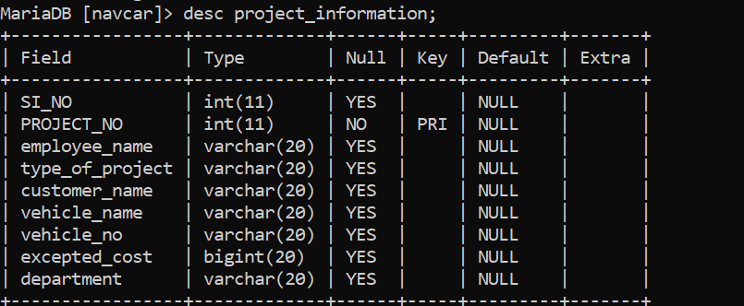

CUSTOMERS :

This table contain the details of customers such as customer id, customer name ,mobile number, type of project work, vehicle name, vehicle number, project no.

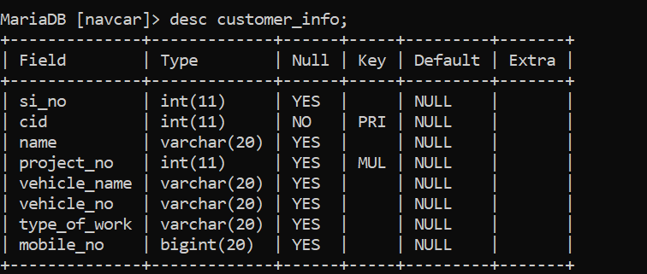

EMPLOYEES :

This table contain the details of employees such as employee id, employee name, project no, age, salary, mobile no, department.

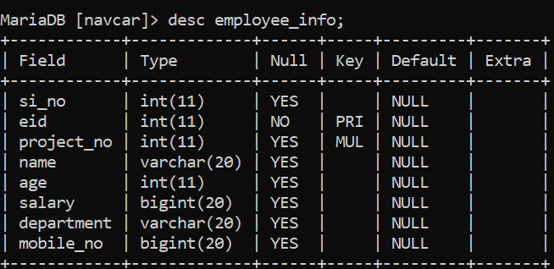

TOOLS:

This table contain the details of tools such as tool id, tool name, department , type of work, project no.

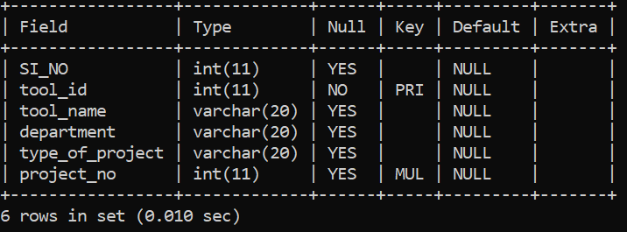

CONTENT OF TABLES

PROJECTS :

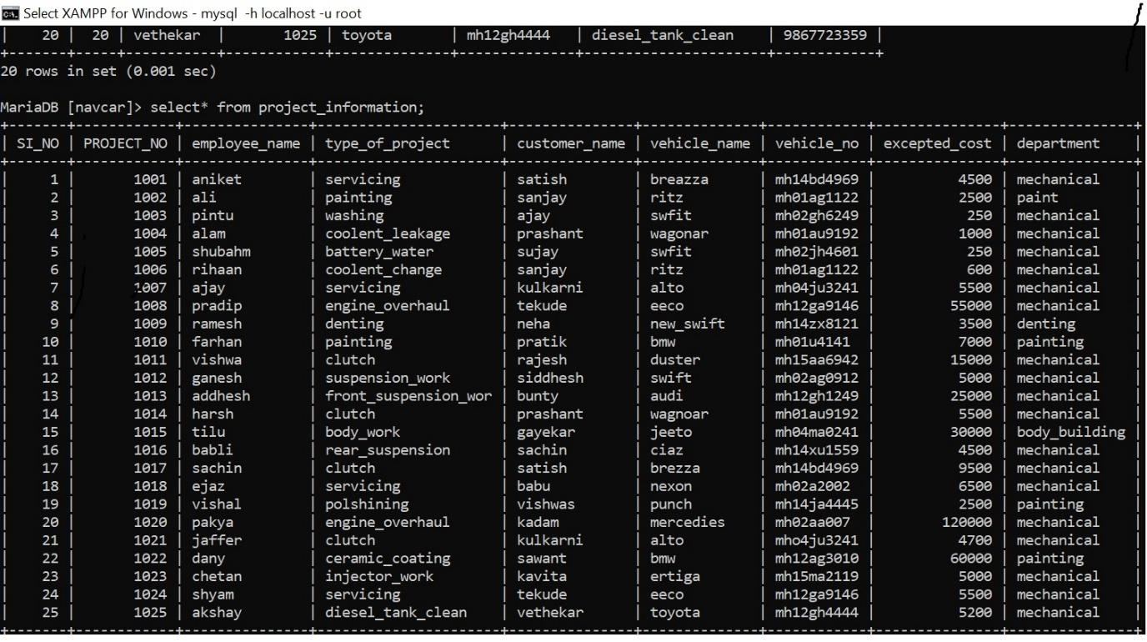

CUSTOMERS :

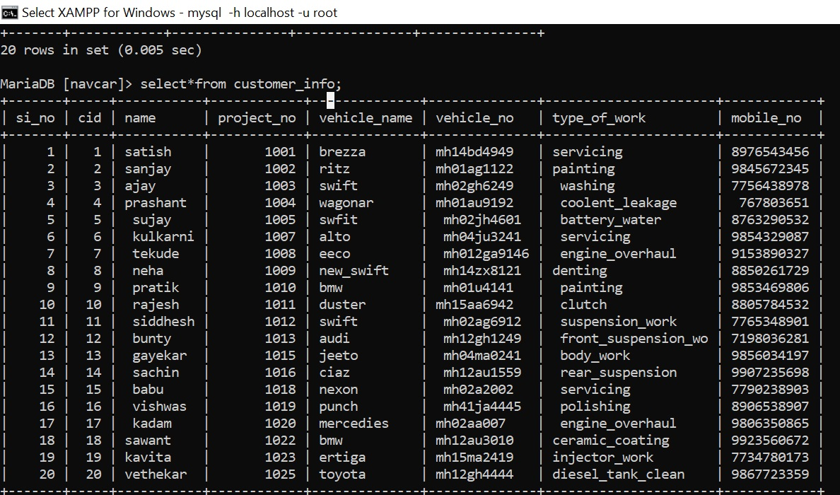

EMPLOYEE :

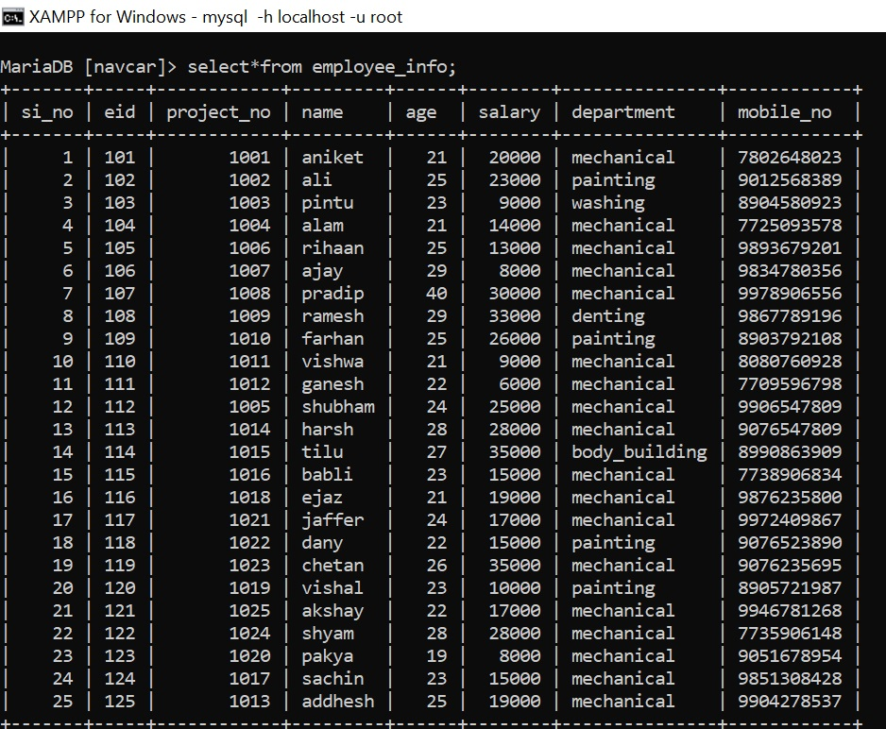

TOOLS:

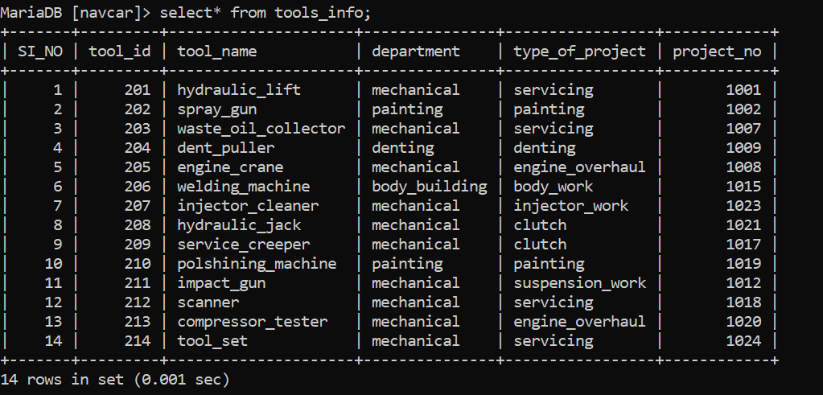

QUERIES

1: Show the details of the employee who has age>20 and salary>30000.

select * from employee_info where age>22 and salary>30000;

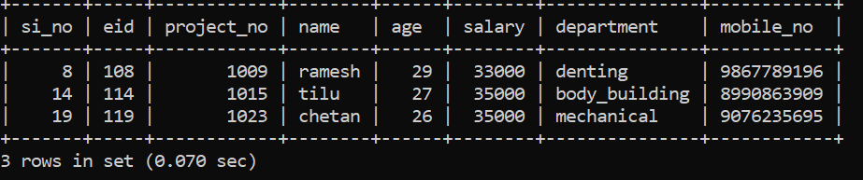

2: Show the details of the customers who has a swift or work type is servicing.

select * from customer_info where vehicle_name='swift' or type_of_work='servicing';

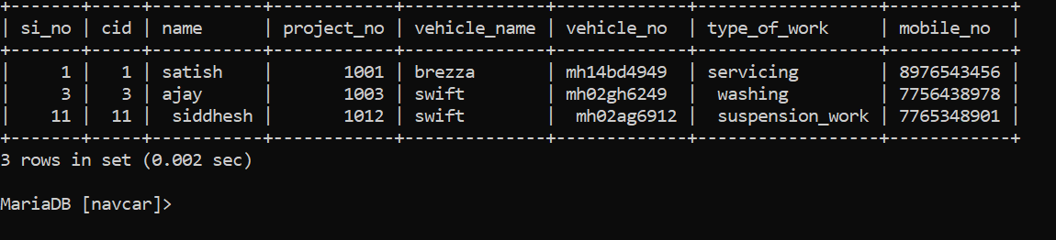

3: Show the details of the project information which customer name start with letter “s”.

select * from project_information where customer_name like "s%";

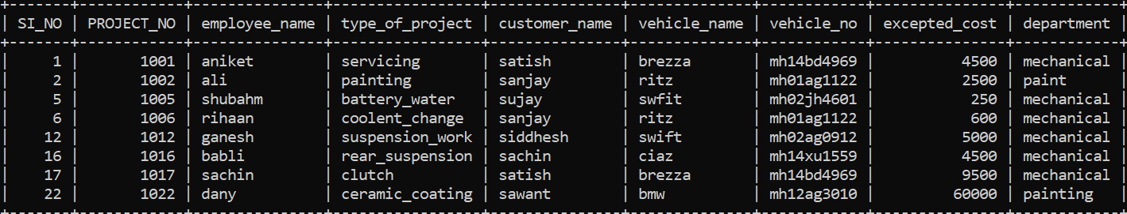

4: show the details of the employee who has a salary between 20000 and 30000.

select * from employee_info where salary between 20000 and 30000;

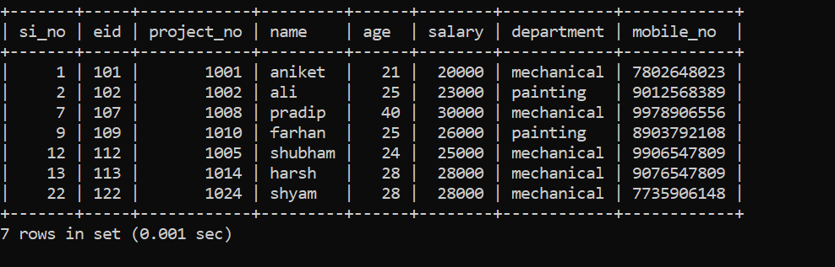

5: show the details of employee which not in ‘mechanical’ department.

select * from employee_info where not department= 'mechanical';

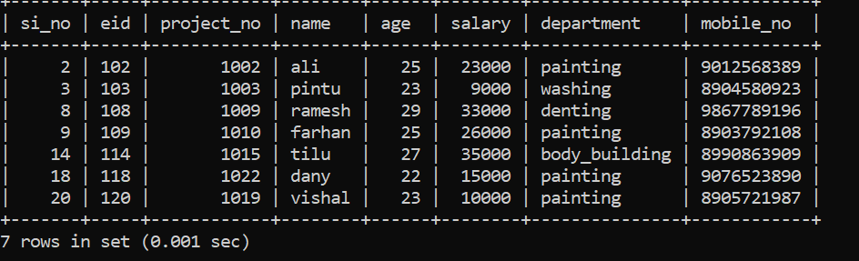

6: Show the details of employees order by salary.

select * from employee_info order by salary;

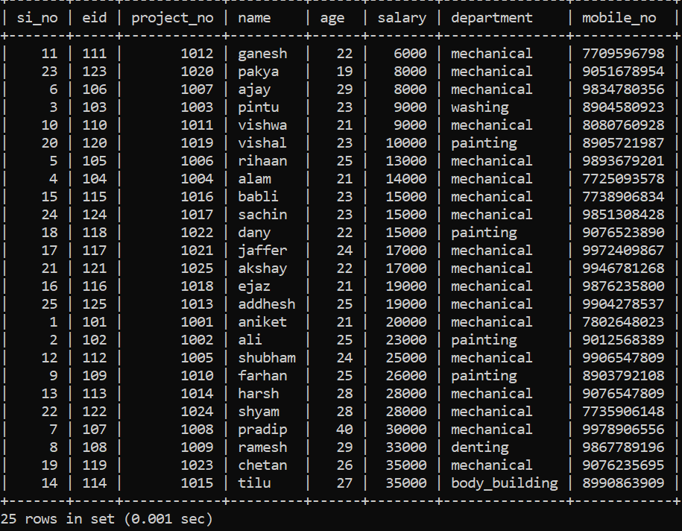

7: find the total salary of employees by department.

select sum(salary),department from employee_info group by department;

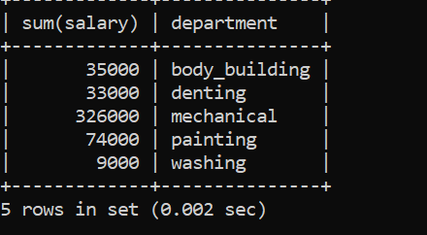

8: Count the customers by their type of work.

select count(cid),type_of_work from customer_info group by type_of_work;

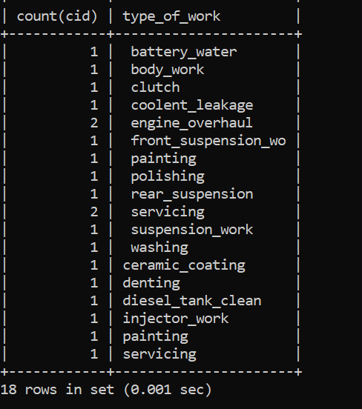

9: find the lowest salary of employee of each department.

select min(salary),department from employee_info group by department;

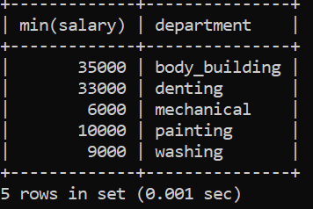

10: find the highest salary of employee of each department.

select max(salary),department from employee_info group by department;

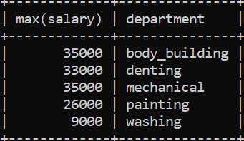

JOINS

1: Display common columns between employee and customer information.

Select customer_info.project_no,customer_info.name,employee_info.name,employee_info.eid,customer_info.cid from customer_info inner join employee_info on customer_info.project_no=employee_info.project_no;

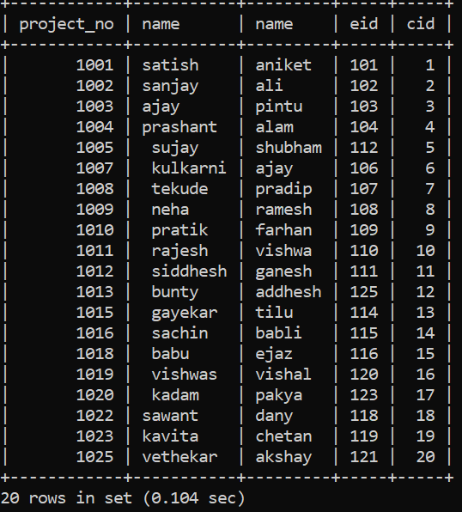

2: display project information associated with the customer information

select project_information.project_no,project_information.employee_name,project_information.excepted_cost,project_information.department,customer_info.name,customer_info.mobile_no,customer_info.cid,customer_info.type_of_work from project_information left join customer_info on project_information.project_no=customer_info.project_no;

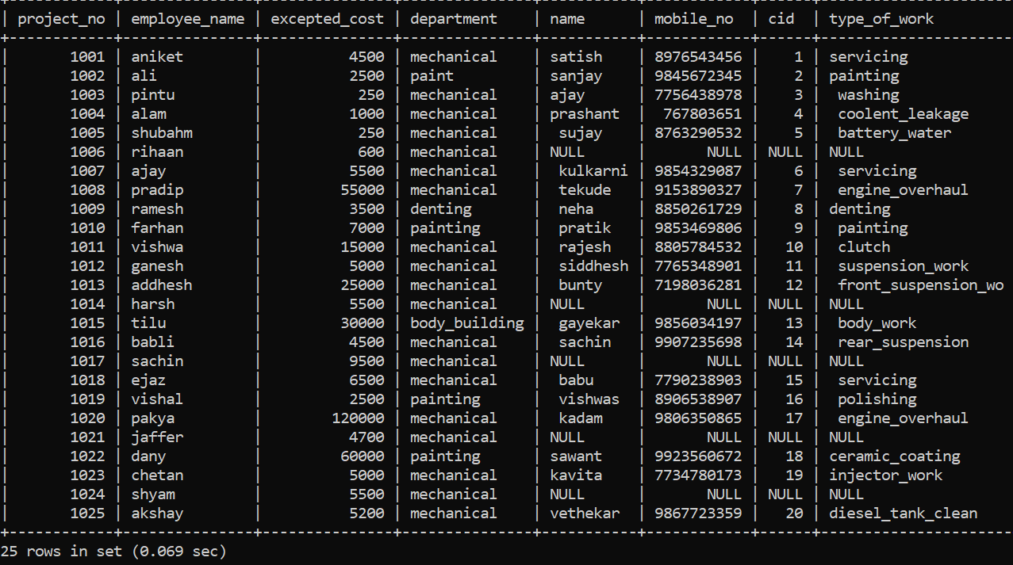

3: Display employee information associated with the customer information.

Select customer_info.cid,customer_info.name,customer_info.project_no,customer_info.vehicle_name,customer_info.type_of_work,employee_info.eid,employee_info.name,employee_info.salary,employee_info.age,employee_info.department from customer_info right join employee_info on customer_info.project_no=employee_info.project_no;

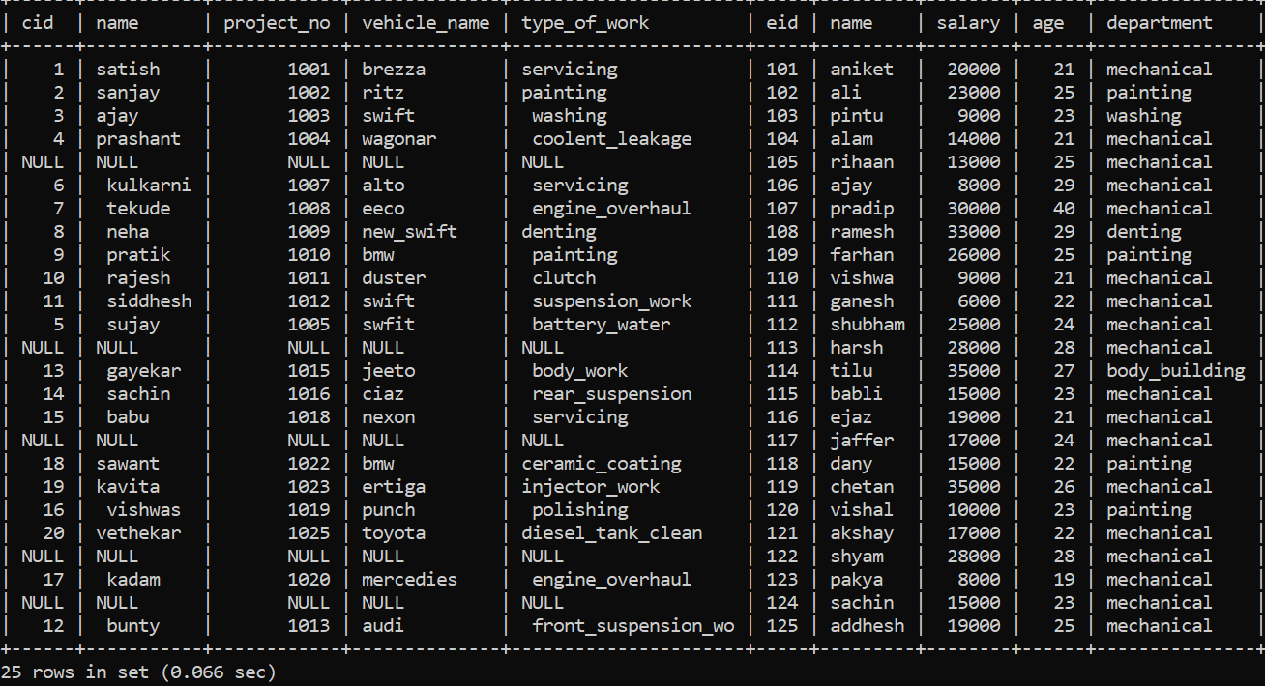

SUBQUERIES

1: Show the details of the employee who in mechanical department with salary>20000.

select * from employee_info where project_no=any(select project_no from project_information where department='mechanical') having salary>20000;

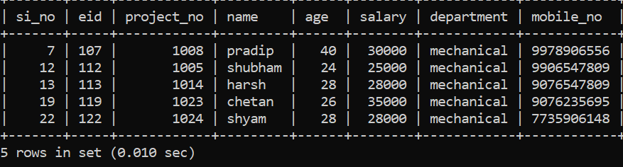

2: Show the details of employee who was worked on the brezza, jeeto ,eritga.

select * from employee_info where project_no=any(select project_no from customer_info where vehicle_name in ('jeeto','brezza','ertiga'));

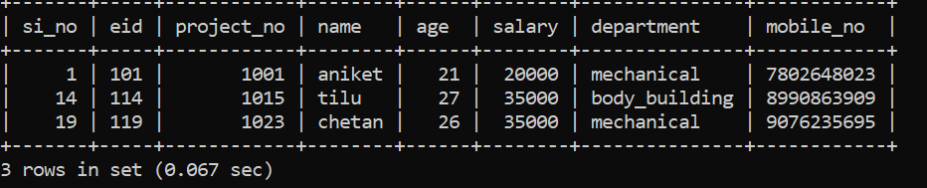

3: Show the details of customers who has excepted cost>30000;

select * from customer_info where project_no=any( select project_no from project_information where excepted_cost>=30000);

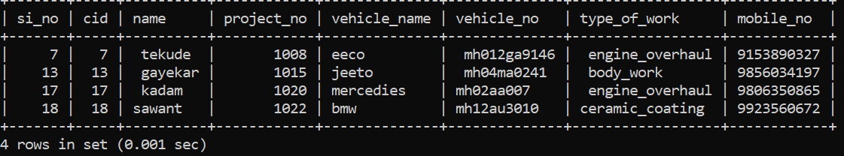

4: find the name of customer which employee salary>13000 who worked on customer car.

select name from customer_info where project_no=any(select project_no from employee_info where salary>13000);

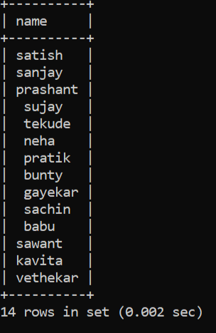

5: how many customers from customer table has a project in painting department.

select count(cid) from customer_info where project_no=any(select project_no from project_information where department='painting');

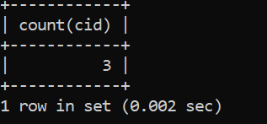

6: Show the details of employee who use ‘engine crane’.

select* from employee_info where project_no=(select project_no from tools_info where tool_name='engine_crane');

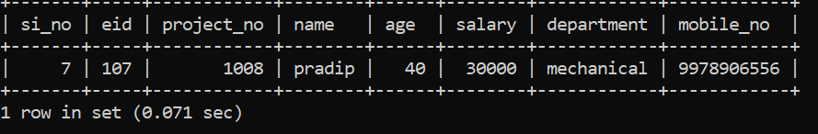

7: show the details of tools which used for customer ‘satish’.

select* from tools_info where project_no=any(select project_no from project_information where customer_name='satish');

